Script-Controlled ACL restrict record access based on field value

Project Overview
Milestone 1: Creation of user and roles
User creation:
1.Log in to the ServiceNow instance with admin access.
2.Create a test user:
- Navigate to User Administration → Users
- Click New
- User ID: EEE User
- First name: EEE
- Last name: User
- Email: eeeuser@gmail.com
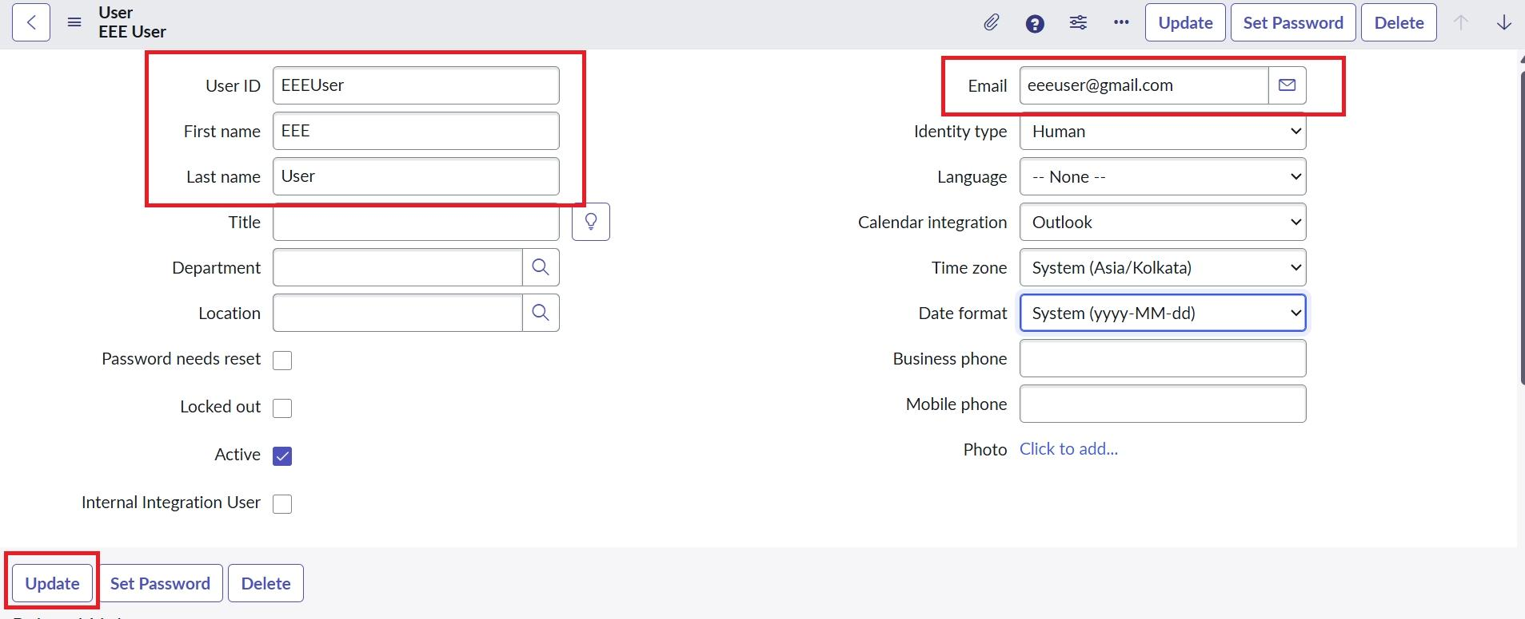
- Save the record
Role creation:
- Navigate to User Administration → Roles
- Click New
- Name: Enter role name as bb1
- Description: Brief role purpose
- Click Submit
- Create other roles also like bb2,bb3,bb4.(follow the same procedure)
- Assign all the roles to the EEE User
